Framework (https://www.figma.com/file/U4TpZQrU8yvK3uUFJylfcm/Ian-Shovlin's-team-library?node-id=0%3A1)

Similar to Twitter, web for public and open surveys

Survey answers are private but open to anyone

English/Spanish surveys (use code from other apps created)

Register using phone(use code from other apps)

Password verification(use code from other apps created)

Going to prompt the user for the age

Asking user for gender

Asks for zip code(or should this be location)

Different types of surveys

Users can create surveys(max title is 200 words in length, or 200 characters?)

Users can vote for polls they wish to have(only 1 vote? And a little confused on this)

Different types of questions with different types of responses

User can consult results of any survey if they wish

Results of surveys are shown by percentage

Searching for surveys using keywords(similar to twitter displaying from most popular to least)

**Display Written Out:**

First Screen: Age(separated by groups( <= 20, every 10 ages after(21-30) (similar to twitter account)

Second screen: (Actual use of the app after creating account and login / Twitter search and tweets, etc)

Creating Survey button

Ask questions about that, Surveys to create(age range, scope)

My survey button(shows surveys that user has created)

User can favorite a survey then find it easier

User can search for surveys created in or near their region(see if political party is the same, view on other things)

Are we paying users who answer surveys(if so can they get the money to their bank, how much per survey(depend on length?))

100 surveys answered is the max(can they make another account?)

Should there be a minimum age?(13,16,18)

**PROJECT DESIGN**

Define Project Goals:

The goal of Sociality is to create an application that is similar to Twitter but based on surveys. The goal of it is to allow social opinions for a variety of areas and it allows to socialize the opinions of any citizen.

Determine Outcomes:

We will have an app that will allow users to create their surveys and publicly post them. There will be a trending page for the most popular surveys. There will be a calculated price for the amount the user will get paid for per survey and there is a max of 100 surveys.

Identify risks and constraints:

Not too many people will use the app due to their being similar apps including surveymonkey. Would have to make some significant differences between the two. Also, it is difficult to calculate the absolute value and % of the sample.

Refine your strategy:

This is shown in the drawings and the website template for how the app will look(looks similar to twitter in a way)

Estimate your budget:

Shouldn’t cost anything extra.

Creating a contingency plan:

We will have an app that will allow users to create their surveys and publicly post them. There will be a trending page for the most popular survey. Make it different from other survey websites so people use it over other websites and applications.

Document your milestones:

Starting the internship

Finishing Framwork

Update and add more as we go

**Questions We Have:**

How to monetize? Ads?

Marketing Strategy?

Color Scheme? Logo and other assets?

How are we going to differentiate this app from other survey apps and websites?

**Some Ideas we have:**

Ads

Minimum age is required

Asks user for zip code(same as other app Elsetic has created)

Add likes and dislikes

Add a trending section

Face ID login on mobile

Can't allow user to create more than 1 account if there is a max of 100 surveys because then they would make more accounts to answer more surveys

After the 100 surveys, allow user to do more for free or small donations

Allow for notifications and allows the user to choose what they want notifications for

Add to possible answers(Shown on screen templates),(Strongly disagree, Strongly agree), similar to interview questions

Add more scopes for surveys(Entertainment(music, sports, games, movies))

Ability to sort feed(most recent, most viewed, most upvotes)

Report button

**Descriptions of screens and functions for display template:**

Home screen: displays the surveys and the user can scroll through. Shows when the survey was created, who created it, and the title. The user can

Vote on any survey by selecting their choice in which a submit button will pop up.

Upvote: Similar to a like on other platforms

Downvote: Similar to a dislike button

Add: Users can add surveys they like to their favorites tab

New survey: allows users to create a new survey that is added to their ‘My Surveys’ tab and added to the home screen for other users to see.

Home button: Refreshes the screen.

Search: goes to the search tab where users can search for surveys or users with key words.

Notifications: Goes to notifications tab where users can see recent actions.

Settings: Switches to settings tab.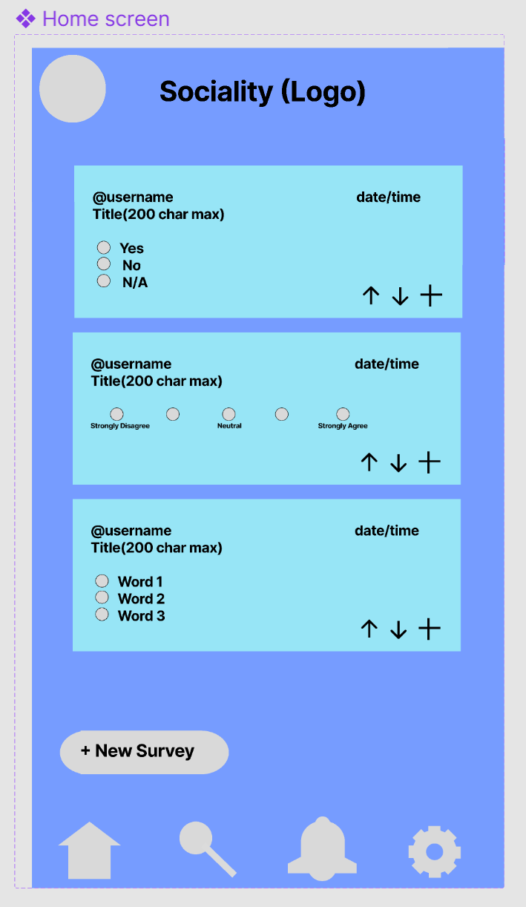

New Survey Screen: Allows the user to type out the name of survey and chose the scope and style of the survey. If they survey type is words the user is asked for the number of words and is then prompted to enter the words.

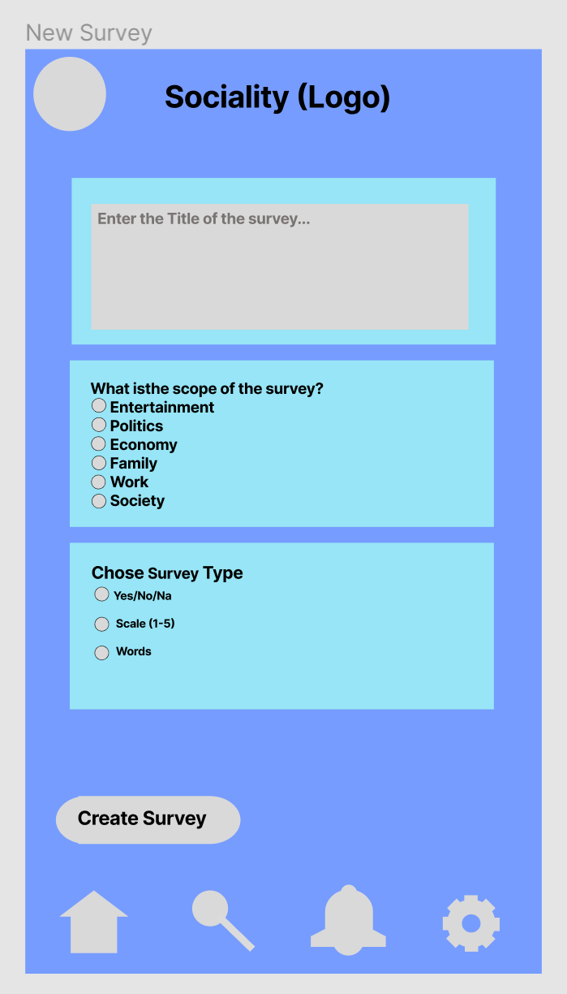

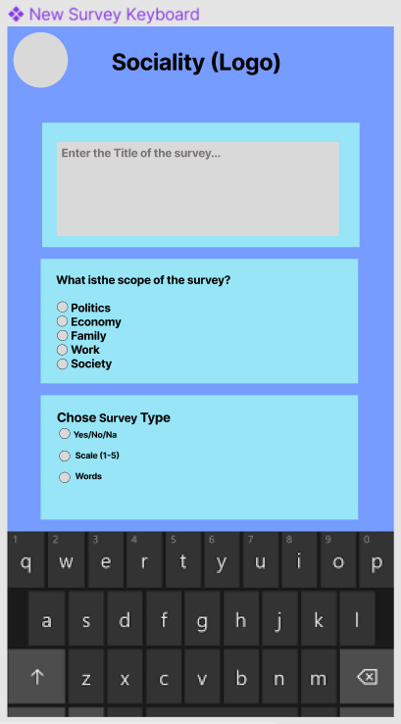

Profile: Contains the users surveys and bio and for ones own account it displays favorited surveys, upvoted surveys, and allows the user to edit their profile if needed.

My Surveys: Displays the surveys posted by the user.

Trash button: allows users to delete a survey they created.

Favorited Surveys: Displays the surveys favorited by the user.

Minus button: allows users to remove a survey from their favorites

Bottom buttons are the same as stated above.

Upvoted Surveys: Displays the users upvoted surveys. User can remove their upvote to remove a survey from this tab.

Edit profile: User can edit their username, location, birthdate, and password as needed.

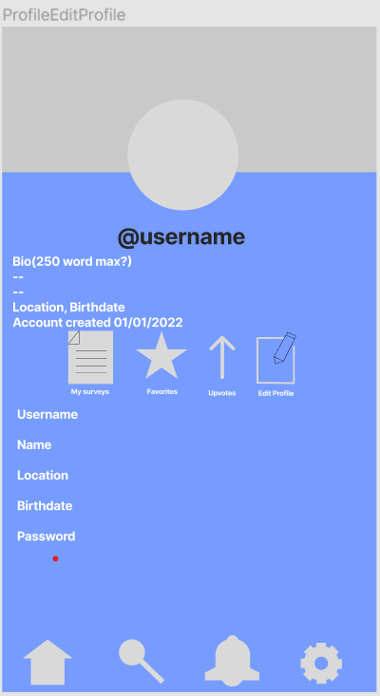

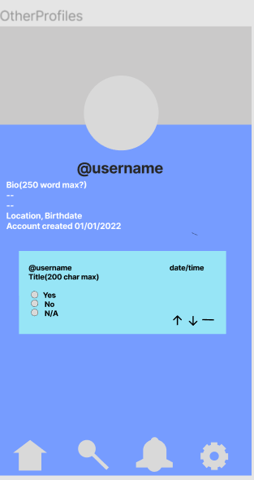

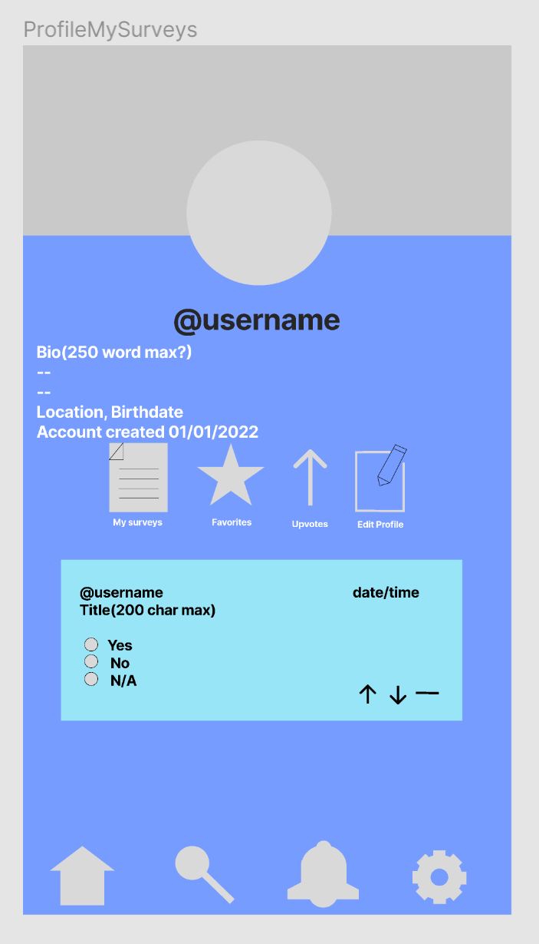

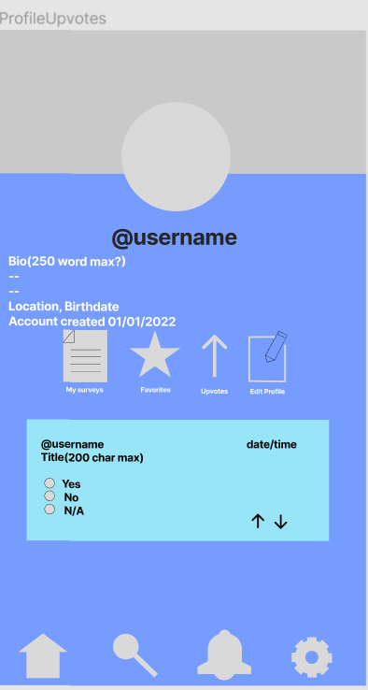

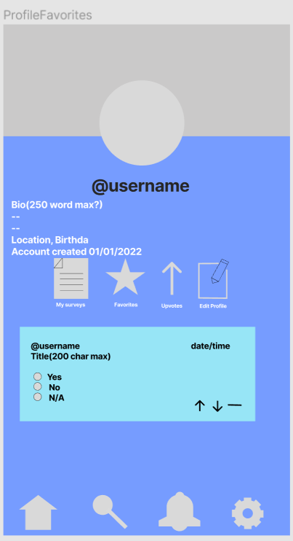

Search: Allows the user to search for surveys or users based on keywords. The user can also look at trending (most popular) or recommended (based on favorited surveys) by using the buttons located at the top.

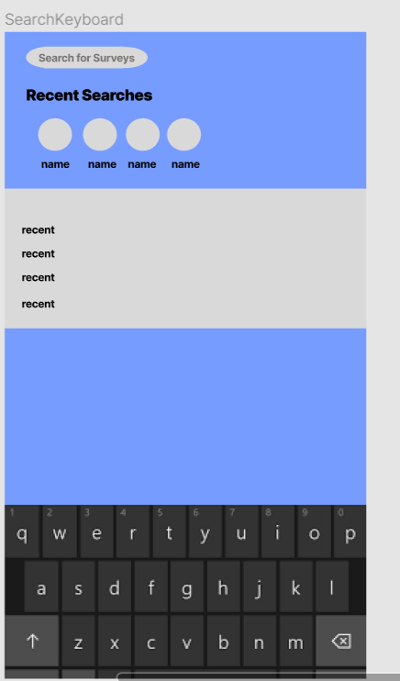

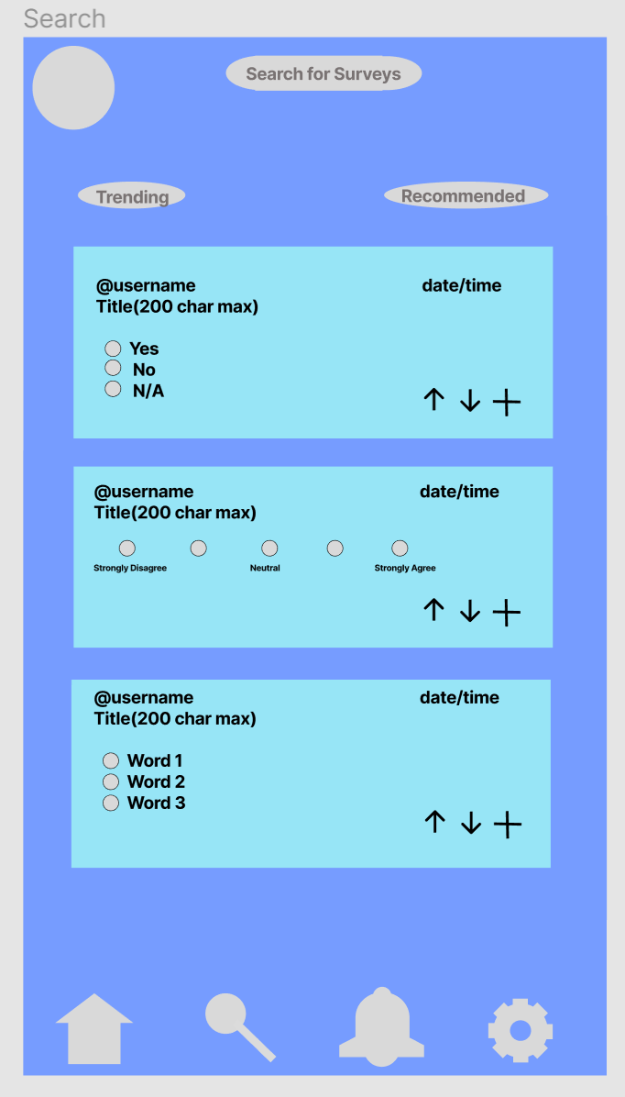

Notifications: Displays notifications for the following

When a user favorites a survey the user created.

When a new survey is created by a popular user.

The number of upvotes received on a survey the user created.

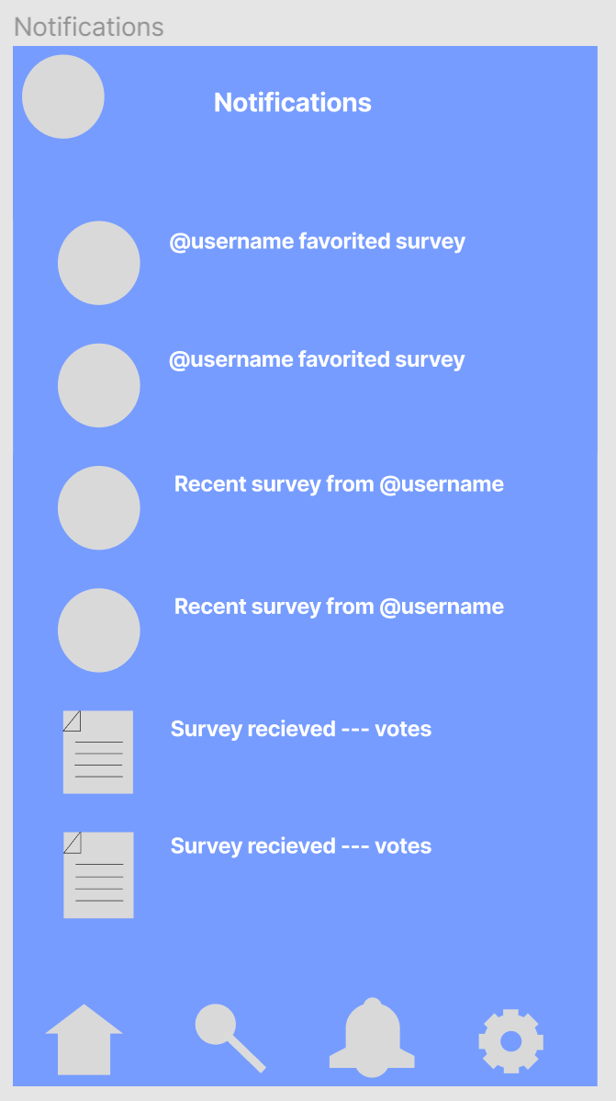

Settings: Basic settings the user can use

Log out: logs the user out of the account.

Dark mode (idea): Users can switch the theme of the app to be easier on the eyes.

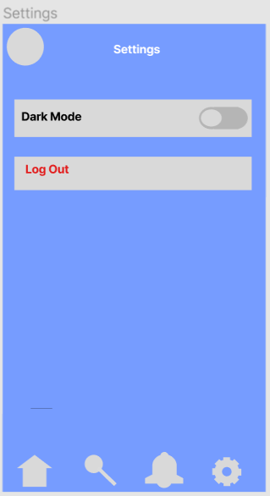

Below are templates for each of the screens mentioned above:

